

Quality of Education

Saint Philip Howard Catholic Voluntary Academy

Staff Reference Guide 2025-26

- Quality of education - overview
- SPH - Curriculum Expectations
- T & L Priorities 2025-2026
- Implementation: Lesson Planning
- Key Stage 3 Assessment
- Marking and feedback
- Work Scrutiny
- Homework 2025-26
- Student intervention
- Reading and
Literacy across the Curriculum
- QA: Support and Challenge

Section 1: QUALITY OF EDUCATION

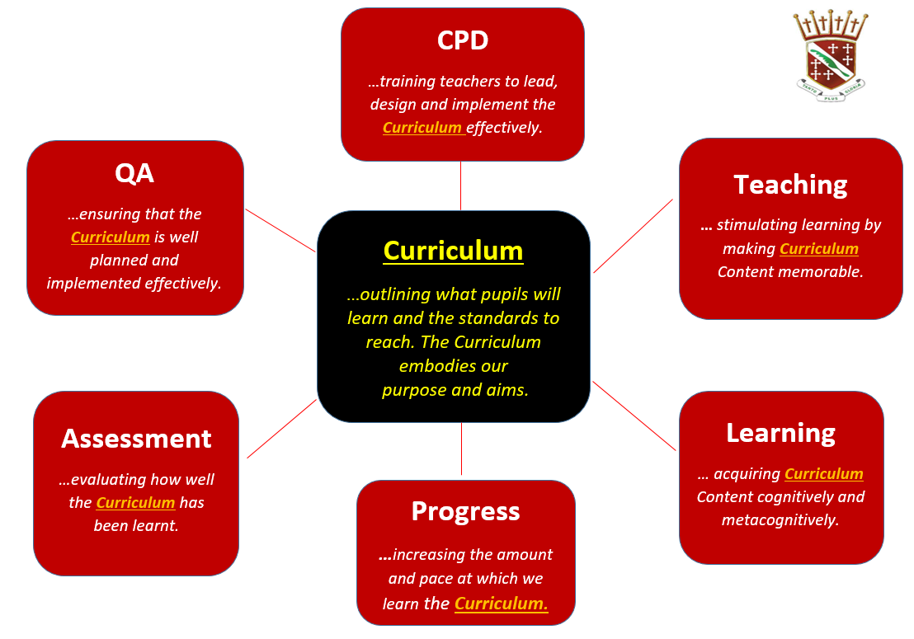

Our curriculum sits at the centre of everything we do and offer as a school. All of our decisions are centred around what we believe is best for the individual Student. We believe our Curriculum will have a positive impact on Students’ learning and progress, therefore, support them on their ‘Success Journey’ into further education or employment.

In order for our Curriculum to have its intended impact, we must:

- Ensure that our school is meeting the standards it has set itself by supporting staff in all forms of CPD and QA. Staff professional development is rooted in the needs of the school and, these are aligned with the curriculum which results in better teaching for our students.

- Ensure that the curriculum and provision is carefully mapped for ALL - this encompasses those students that have an EHCP or SEND needs, as well as Students who are PP/ receive FSM.

- Ensure that what happens in the classroom reflects the highest standards of Teaching and Learning and Students are provided with quality-first teaching throughout the school by ensuring that teachers:

- Have consistently high expectations and set work that meets the needs of all students so that they become resilient, independent and metacognitive learners.
- Encourage Students to learn more and remember so that they can make connections between their learning and deepen their understanding.
- Encourage students to better articulate their understanding in lessons through discussion.
- Ensure Students fully engage in Homework to consolidate their learning.
- Enhance Students’ literacy skills and vocabulary retention to aid comprehension.
- Provide feedback to students’ that is consistently in line with the school’s policy so that students know how to refine and improve their work.

- Finally, some students will require greater pastoral support than others but all will benefit from effective leadership at all levels: SLT Mentoring, Pastoral Managers, Heads of Year/Heads of Department, Form Tutors, as well as different forms of Peer Mentoring.

Section 2 - Curriculum Expectations
Key Stage 3 and KS4

Our balanced and dynamic curriculum encourages constant reflection and refinement and this is continually reviewed with the focus on:

Intent – What we will teach and when/ how it links to prior/ future/ cross-curricular learning.
Implementation – How we will teach/ deliver and ensure learning is memorable and sticks.
Impact – How successful the learning has been; what needs to be revisited/ when and how.

Core Curriculum Expectations:

- The knowledge rich KS3 curriculum will have a positive impact on Students’ progress. It will demonstrate progression in structure, setting out what we want our students to learn and therefore the progress we expect them to make in developing and refining their knowledge and skills. Focus will be placed on ‘knowing more, remembering more’

- The whole school Curriculum develops Students for the next phase of education, training or employment and leads Students towards their ‘Success Journey’.

- The Personal Development / RSHE Curriculum also develops and deepens the Social, Moral, Spiritual and Cultural focuses, as well as the British Values and Cultural Capital.

- There is a clear focus on developing a reading culture and metacognitive strategies across all year groups so that Students can develop transferable skills which will support them to become life-long learners.

KS3 Curriculum Planning – all subjects have:

- Subject Intent and Curriculum mapping which shows carefully considered sequencing and spaced learning and is at least in line with National Curriculum Framework if not more ambitious.
- Key Skills and Knowledge mapped for development.
- The Key Terms which should be learnt/ are applicable to the Core Knowledge/ topic being learnt.
- Planned opportunities for revisiting.
- Departmental Assessment Plans/ Progress Indicators.
- Planned Formative checkpoints and Summative Assessments that focus on demonstrating how well knowledge has been learnt/ skills have been developed throughout the term/ throughout the year as a whole.

KS3 Subject Planning will:
- Directly relate to the overall Subject Intent.
- Will provide opportunities for interleaving/ revisiting.
- Clearly state assessment points.
- Demonstrate where retrieval/ revisiting is evident – across topics/year/ key stages.
- Show explicit links to Literacy/Reading or Cross Curricular links where appropriate.
- Show explicit links to SMSC/ BV.

KS4 Curriculum Planning – all subjects have:
- Curriculum mapping which builds progression from KS3.
- A clear plan for spaced repetition/knowledge retrieval practice.
- A subject structure for both Summative and Formative assessment.

Section 3 – SPH Whole School Teaching & Learning Foci for 2025-26

Key areas for the academic year will focus on:

Knowledge retrieval/Spaced Repetition:
- Aim to reduce the forgetting curve.
- Improve knowledge retention over time.
- Include opportunities for knowledge re-visits across all topics, over the entire academic year/ key stages.
- Embed the RRR tasks into starter/ checkpoints throughout lessons.
- Refer to KS3 Assessment Framework to support students in ‘knowing more and remembering more’.

Questioning and Articulation:
A vital pedagogical tool, as we seek to ensure Students’ progress and provide continuous dynamic feedback is through questioning which prompts deeper thinking. Effective questioning is an entity in its own right and supports the success of embedding our other key Teaching and Learning themes.

You may wish to use the following:
- Direct/ targeted questioning – use the student name AFTER you say the question.
- Question phases where Students are/ are not allowed to put their hands up.
- Phone a friend – allow students to seek support from another to help them in their articulation.
- Questioning which reaches everyone: Ability/ PP/Gender/SEN/ and this can be differentiated as applicable.
- Utilising the question framework/metacognitive questions/CUSP questions to allow all students (not just the more able) to summarise, synthesise, justify and evaluate knowledge.
- A specific task that asks for deeper thinking– not give more questions to be completed.
- Link to Key Concepts, Symbols, Knowledge and Skills.
- Use questioning to enhance Students’ Literacy.

Deliberate Practice/ Skill Development:
- Deliberate practice is providing a planned opportunity for students to work independently completing tasks which ask them to consolidate prior learning, apply their new knowledge, and focus on well-defined specific goals, which ultimately push them beyond their comfort zones.
- In practice it means being very mindful of ‘teacher talk’ and allowing students the learning space to move forward, reduce ‘compliance’ and increase independent completion of work and student stamina and resilience.
- Lessons or short sequences of lessons should be planned so that key knowledge can be embedded.

Reading and Literacy:
- Explicit Instruction/ teaching of vocabulary:
Staff should model the standards they expect in reading, writing, spelling, grammar and punctuation, as well as articulacy. Tier 2 and Tier 3 vocabulary must be taught explicitly with baseline tests and regular Key Term tests throughout a scheme of learning.

- Whole school reading strategy:
CUSP should be used to help all Students (of different abilities) to tackle an unseen text in any curriculum area. This should aid Students to find ways of making links to prior learning; comprehending meaning; summarising and synthesising as well as understanding the reasons/ choices for specific texts and how this can help them to decode further.

- Marking for Literacy: please see Feedback (Section 6).

Feedback & Re-visiting:

Feedback to students is about a ‘dialogue’ or conversation between the teacher and the student. This can be through:
1. Verbal Feedback/ Live Marking in class – personalised feedback between teacher and student.
2. Learning Checkpoints – Formative comments in marking cycle which Students should respond to.
3. Re-visiting/ re-teaching lesson phases – ‘have students developed a secure knowledge’ of the curriculum? What needs to be re-taught?
These will be reactive and formative but can be guided through Class Feedback Forms, point marking or DIRT activities.
Re-visit/DIRT lessons will form a vital part of the conversation between class teacher and students. The structure of these lessons will fall outside the ‘norms’ of what a lesson may look like in your subject, but that is to be expected. What is important is that we address areas where student knowledge is insecure/absent or where misconceptions have occurred. These re-teach lessons/ lesson phases should be clearly identified and show how they have addressed misconceptions.

Feedback will also be provided in the following ways:

- Knowledge Quizzes- Peer/ Self assessed
- Key Term Quizzes- Peer/ Self assessed
- Live Marking- Teacher assessed
- Multiple choice activities
- Varied Homework set on class charts and recorded in planners (Teacher provides Formative feedback)
- Formative Checkpoint pieces (Written feedback WWW, EBI in books)
- Class Feedback (Teacher verbally, Students- written)
- Practice Papers- application
- Summative assessments- Teacher assessed- Deep marking and DIRT

Homework:

Core Homework must be set once a week.
- Weekly Homework will be set and marked on ‘Century’.
- Longer pieces of written Homework will be set and marked (with formative feedback) as directed by the HOD.

Other subjects must set homework once a fortnight.
- This will be set and marked using formative feedback

Section 4 – SPH Lesson planning and structure

Lesson planning must consider / include all of the aspects below:

- The Intent and objectives of the lesson (Head Heart and Hands)
- An overarching Key Question – written in exercise books as the lesson title
- The Key Skills and Knowledge Students will be learning.
- Key Terms/ vocabulary Students must retain.
- An RRR task to make links between prior and future learning.
- How the content/ key concepts will be implemented/ delivered effectively.
- How learning may make cross-curricular links/ support Literacy or Numeracy.
- How progress will be assessed in the lesson. (Metacognitive plenaries, self/ peer assessment etc).
- How Homework will support Students to know and remember more.
- How Students will receive timely, impactful feedback to aid further progression. (Live Marking, Class Feedback, Deep Marking).

Lesson Structure:
Lessons at SPH should utilise the different aspects of The Learning Journey and begin with a Speedy Start

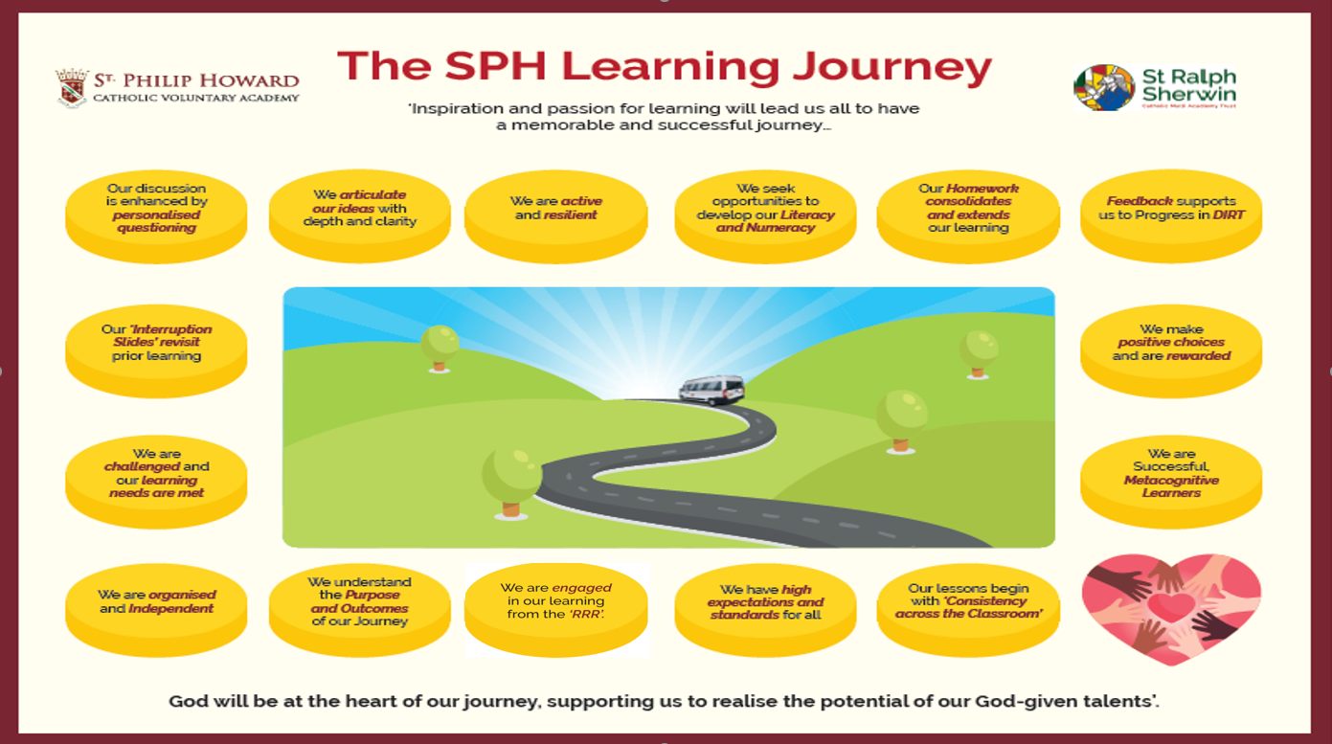

Some suggested elements for each Lesson are shown below:

Lesson Element | Suggested activities/explanation
RRR Task | As students walk in and settle:  - Knowledge retrieval questions  - Low stake quiz  - Label the image/ symbol  - Close passage  - Define the key terms  - Complete a section of a Knowledge Organiser
Learning Objective/  Skills and Knowledge | The ‘big picture’ for the lesson.  - What is the focus and why is this important?  - Explain/outline what knowledge Students be learning.  - Explain/ outline what skills Students will be developing.
Implementation:  Modelling/ Instruction | Share the task/s:  - Soft support :‘what a good one looks like’  - Scaffolding: E.G: sentence starters and/key vocab to be included.  - Stating the outcome.  - Reading unseen text- use of CUSP to interpret independently.
Implementation: Deliberate Practice | Completion of work:  - Students independently complete tasks that embed learning.  - Can be planned to encompass individual and pair/group work.  - Outcomes are clear and the focus is directly related to the overall Learning outcome/ success criteria (Progress Indicators).  - Opportunities for mini-plenaries/ metacognition.  - Check understanding/correct misconceptions and judge competencies.  - Encourage participation in Deeper Thinking tasks.
Plenary | Lesson reflection:  - Assessing progress against the learning outcome/ progress indicators.  - Using skilful questioning to move ideas forward.  - Deeper Thinking task reflection.  - Skills and Knowledge reflection.  - Self/ Peer Metacognition questions.  - Link to future learning.

Section 5 - Key Stage 3 Assessment Framework

Key Stage 3 students will all be given a Progress statement that is linked directly to the curriculum outcomes expected in an individual subject, across an academic year.
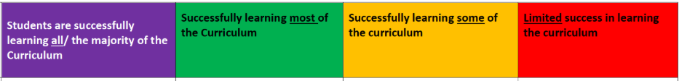

This assessment model will see students across Years 7 to 9 regularly assess progress through the curriculum; support the re-teaching of curriculum content and skills and reduce the need for unnecessary workload.

Assessments will be meaningful and synoptic and data entry will be limited to allow for teachers to plan and deliver the curriculum in the most effective way.

SPH Assessment Process for KS3

“Assessment is fundamentally about evaluating the extent to which pupils have successfully learned the curriculum (or not)” L Northern Director of curriculum E-ACT Curriculum strategy.

Frequency | Assessment | Link to curriculum | How it is assessed  *Also refer to marking & feedback policy | Intended Impact
Daily/Every Lesson | Retrieval questions to assess knowledge and retention | Every unit of work should have set pattern of retrieval questions/ Knowledge quizzes. | Self/whole class assessment.  Re-teach and re-test gaps until knowledge is secure. | Regular low stakes quizzing is essential for long term retention of knowledge.
Weekly | Students apply the knowledge and subsequent skills they have developed through lessons and complete a specific Deliberate Practice task.  These learning checkpoints should be appropriate (in length) to the knowledge being tested. | Medium term planning in every subject should identify which Deliberate practice Learning checkpoint needs to be completed in the sequence of learning. | Teacher to cursory mark ensuring that whole class feedback is given in WWW and EBI format.  They then re-teach the gaps. | All evidence indicates that regular formative assessment and the feedback that comes with it has more impact on student progress than summative assessment. Students will be able to ‘to do more’ with their knowledge.
Each Term  Two Summative Assessments per Term.  CORE  One Summative assessment per term  NON CORE  Two knowledge quizzes every half term  ALL SUBJECTS | Students sit at least two knowledge tests a half term.  These can be multiple choice – knowledge based content questions which are self/ peer marked in class. | The content of curriculum for each year – to date -will be assessed to ensure there is an accurate record of students’ progress. | Summative assessments will be teacher marked with detailed feedback (WWW and EBI) and where applicable recorded as a % and compared to the class % average.  Knowledge quizzes can be peer assessed | Regular Knowledge Tests throughout the academic year will assess Students’ knowledge from September onwards and will record the progress of students’ acquisition of long term knowledge. The use of summative assessments termly, which result in a final summative of the year, will show Students’ progression throughout the whole curriculum.

Recording and Reporting student progress
GCSE Levels will only be used once students are following the GCSE exam specification leading to externally sat GCSE exams in Year 11.
In KS3 Teachers will enter one Progress Level for each student three times per year
Parents/Carers will receive three Progress Reviews which will use the statements – not Levels or grades- as this makes a clearer distinction from GCSE Levels and grades. These will also include Attitude to Learning for each student in each subject.

It is essential that:
- Retrieval practice (the format of Knowledge quizzes) and Learning checkpoint activities (Formative assessments) are standardised across subject areas.
- Student work is moderated before data submission in the Progress Reviews.
- After each Assessment Point Curriculum Leaders moderate results and progress grades awarded. Consider -Are all students working at the same level? Are all students accessing the curriculum to the same standard? Are there data anomalies between teaching groups in the same subject?

Section 6 - Marking and feedback: Core Principles

Feedback expectations

Verbal feedback is the most frequent form of feedback; it has immediacy and relevance as it leads to direct pupil action. Verbal feedback may be directed at groups of students; it may be planned based on intervention strategies or unplanned based on immediate need. One of the most important ways we help students to progress is during a discussion of their work.

Written feedback should be as follows:

- Books must be marked in accordance with the Marking Policy (CORE - There should be 2 summative assessments with detailed feedback per term. This should include a mark, grade, WWW and EBI).
- Live Marking and Maintenance Marking should be present at regular points throughout.
- Students should be responding to feedback following an assessment in DIRT activities.
- Students should respond to other marking (Live, Maintenance or other EBIs in which they have been directed by the teacher).

Re-visit/ DIRT lessons – are an integral part of providing feedback at both KS3 and 4. These should be planned and come after any Learning Checkpoint. Feedback should be on yellow DIRT sheets/ clearly signposted in Students’ books.

For both KS3 and KS4 this is an ongoing cycle of feedback for all students however, prioritising PP and SEN books in each class.

Self-Assessment KS3 and KS4
This type of feedback should form a regular contribution to your lessons. Feedback should be clearly identifiable as self-assessment by the student e.g. using a red pen. This process will be clearly led by the subject teacher using success criteria.

KS3 & KS4 Learning checkpoints
This is a type of formative assessment. We are looking for the retention of knowledge and its stick-ability. This should be used to inform future lessons. These will be used to inform the holistic progress grade given to students in the Assessment Points. Feedback can be individual to the student or whole class.

Summative Termly Assessments KS3
Subjects will conduct a detailed assessment three/six times per year (including end of year assessments). Summative assessments are to be standardised and moderated within departments where possible.

Summative Assessments KS4
GCSE mark schemes will be applied and detailed feedback given – WWW and EBI. Students are expected to reflect, correct and improve their work. This could be at an individual or group level, directed by the subject teacher.
Question level analysis is expected in formal examinations and student Levels to be recorded on trackers.

Literacy Feedback
The literacy standard of pupils is a school wide responsibility. Corrections should be made on Tier 3 words and some Tier 1/2. (No more than 4/5 mistakes per double page so as not to overwhelm students. Please be aware of students with literacy issues.)

The Key for correcting Students’ Literacy across all areas of the curriculum is as follows:

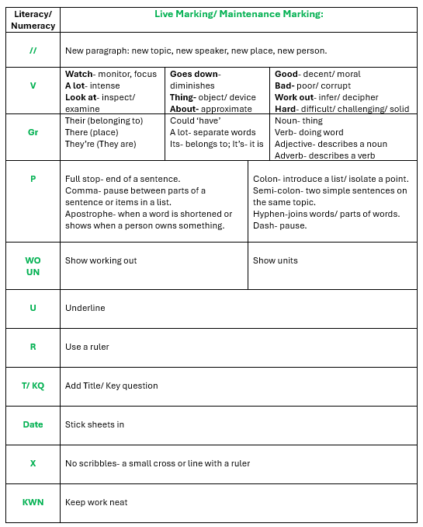

An overview - Student Classwork
Through the academic year, an observer should be able to see how each student has progressed through the subject curriculum.

- The exercise book/ folder etc should ‘tell the story’ of that subject’s curriculum progression.
- Written work should demonstrate the acquisition of knowledge.
- Written work should demonstrate the application of skills.
- Any subject Ofsted ‘Deep drive’ will place a great emphasis on the Students’ books – in order to evidence progress through the curriculum and that the consistency of this is achieved across each subject area.
- Work Scrutiny will be used to primarily analyse curriculum progress – consistency – conversation and anomalies.

Section 7 - Work Scrutiny

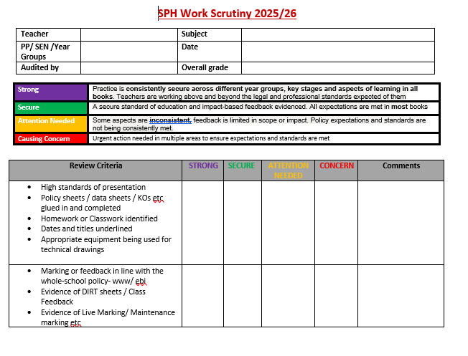

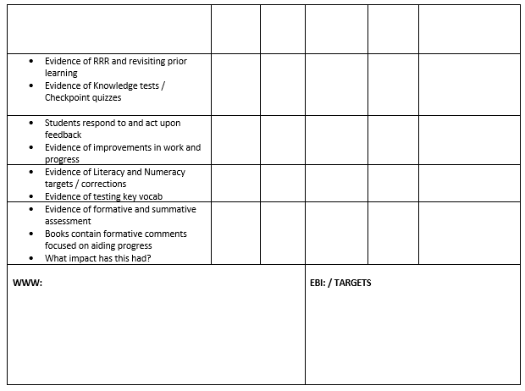

Section 8 - Homework
Core Principles
To facilitate a successful knowledge-based curriculum Intent, implementation and impact across all subjects; homework will be based on knowledge and the retention of knowledge. Therefore, all homework all Years 7 to 11 should:
- Be clearly related to the curriculum being taught.
- Be manageable within the time frame given.
- Be challenging but achievable (differentiated where appropriate).
- Build self-confidence and success – remembering more and knowing more.
- Recognise the work and effort of the student.

Homework should be set and recorded in the following way:
- For Core Subjects, weekly Homework on Century must be set on class charts and recorded in planners. A longer piece of written Homework may be set in addition every fortnight.
- Other subjects must set homework once a fortnight. Homework can contribute towards a longer project for completion at end of the half term but again, Homework must be set and marked with detailed feedback provided

Homework pieces for Year 7 and 8 Students should be between 20-40 minutes.
Homework pieces for Year 9 should be between 30- 50 minutes.
Homework pieces for KS4 Students should be between 40-60 minutes.
(Weekly or fortnightly as applicable to curriculum time).

Homework can be varied and include:
  - Knowledge-based tasks which can be assessed though self/peer marking.
  - Memory retention tasks such as the learning of key terms/ vocabulary for low stake quizzes/ testing.
  - Comprehension and retrieval tasks to develop a deeper understanding of a topic.
  - Independent reading to encourage students to read for pleasure and develop literacy skills.
  - Preparation or planning tasks prior to a lesson so that heightened learning can take place in the classroom.
  - Research-based projects, in order to develop students’ collaboration and/ or independence; stimulate new thinking and enhance skills over time.
  - Real world tasks which prompt students to experience a topic in context.
  - Examination questions to support students’ ability to apply and master skills independently.

Practicalities

All homework tasks (regardless of submission requirements) are set by teachers using pupil planners and class charts. All students will have individual logins and parents will also have access to student homework accounts. Certain pupils with SEN needs will only be required to complete homework for the CORE subjects. This information will be relayed to staff by the SEN department. Home works should be adapted to meet the differing needs of all learners.

Section 9 – Student intervention

All teaching Staff must:
- Know when and how to differentiate appropriately, using adaptive approaches which enable pupils to be taught effectively
- Have a secure understanding of how a range of factors can inhibit pupils’ ability to learn, and how best to overcome these
- Demonstrate an awareness of the physical, social and intellectual development of children, and know how to adapt teaching to support pupils’ education at different stages of development
- Have a clear understanding of the needs of all pupils, including those with special educational needs; those of high ability; those with English as an additional language; those with disabilities; and be able to use and evaluate distinctive teaching approaches to engage and support them.

All teaching staff have an obligation to meet Teaching Standard 5 and provide Quality First Teaching. Supporting students with their learning is everyone’s responsibility.

Types of Intervention in the classroom include:
- Differentiated Skills and Knowledge/ Outcomes
- Differentiated questioning
- Explicit/ direct instruction
- DTTR
- Class Feedback
- Re-teaching
- Modelling/ scaffolding
- Differentiated DIRT activities
- Deeper thinking activities
- Focused nuggets on Century

Section 10 – Reading in the Curriculum/ Literacy across the Curriculum

Reading across the curriculum should be of a challenging enough level to match the age of students and curriculum plan at that point.

Prompting Students to read texts and consider the context, as well as infer meaning is essential in their understanding of any text/topic.

In all lessons, Students should be using their CUSP bookmarks whenever they read an unseen text. All Staff are responsible for promoting and celebrating the message that reading can support Students to become ‘enlightened’ in a number of different ways.

Being able to summarise key points enables Students to demonstrate their understanding and consider how each text delivers its purpose, not only helps with their grammar for reading and writing, but, also enabling them to learn how to apply transferable skills across all areas of the curriculum.
Teachers are prompted to use the WASP and the ‘Closing the reading gap’ strategies in lessons such as:

- Skimming (reading rapidly for a general overview of the text)
- Scanning (reading rapidly to find specific information)
- Slowing down
- Emphasis/ intonation
- Re-reading
- Tracking back through the text
- Checking the index, glossary or scaffolds (students might need this skill modelling)
- Asking questions- active reading
- Summarising (a very powerful tool for teachers to check for understanding)
- Noticing patterns and text structures
- Reading related texts (context/knowledge – might be a good idea to set wider reading as homework)

Reading Approach | Description | Advantages
Teacher-led whole class reading | Teacher reads with students following along. | Models intonation, fluency etc and aids comprehension.
Round-robin | Teacher selects various students who read aloud whilst the rest of the class follows along. | Engages those reading and gives a number the opportunity to develop/ varies voice, tone, register etc.
Choral reading | The teacher and pupils read aloud in unison. | Helps with pronunciation, prosody, engagement and retention.
Paired Reading | Pupils are arranged in pairs and read to one another. This can be done paragraph by paragraph or page by page. | Differentiation, modelling, scaffolding, equal opportunities, confidence, discussion.
Repeated Reading | Pupils re-read a text independently that has just been read out aloud. | Helps comprehension, allows for practise of other skills. More they read the same text, greater fluency. Skill over time is improved.
Individual, Silent Reading | Pupils read in silence and individually. | Opportunity for independence, check comprehension, application of learnt skills.

Section 11 - Teaching Staff Support & Challenge

Teaching staff at SPH can expect to have a programme of support and challenge that focusses around a set calendared events across the year. Key activities will include:

- Learning walks across all year groups and subject areas. These will be conducted by HoDs, T&L Coaches and SLT. They will have a pre-identified focus and learning will be typically observed for 10 to 20 mins.
- Work Scrutiny across all year groups and subjects. This will be conducted at a Subject and Faculty level with staff and Curriculum leaders involved in the process. SLT will also QA this process and look at student work as part of learning walks.
- SLT Line Manager Meetings with HoDs. These will take place fortnightly or as required.
- SRSCMAT Performance Management process. This will cover all staff (with the exception of ECF staff)
- Full Lesson observations are not a fixed part of the academy’s QA. BUT they may be required to meet a particular aspect of Performance Management and they may be part of a Curriculum Leaders/SLT plan for monitoring and subject development. A full lesson observation may be requested after a learning walk to allow Teachers to demonstrate certain aspects of pedagogy and/or delivery. This may in turn lead to coaching or mentoring to support teaching staff.

The CPD on offer to Staff includes:

• Planned CPD courses available to all staff through the CPD Menu.
(E.G: Those based on Career Stage Expectations such as: ITT provision- Teach First, ECT, MDLP, NPQSL, NPQH).
• Planned and suggested online CPD courses in line with school priorities.
• CPD as planned in the CPD Calendar. (CPD directed sessions; CPD based on QA needs, as well as opportunities for cross-curricular collaboration).
• Departmental meetings/ Curriculum planning sessions.
• Focused Working Parties.
• Involvement in networks/ Collaborative groups (MAT training sessions/ Pixl meetings etc).
• Personalised support- Mentoring/ Coaching.
• Individual action research projects which provide opportunities for individuals or small groups to lead on key areas for development and share with the academy.
• External conferences and internal guest speakers.
• Professional dialogue and ongoing Line Management Meetings, as well as continued support in the Performance Management process.
• Shared Implementation strategies and planned partnerships/ discussions with colleagues to reflect on classroom practice.

Appendix 1: Questioning
Socratic Questioning
- Questions for clarification: | - Why do you say that?  - How does this relate to our discussion?  - "Are you going to include diffusion in your mole balance equations?"
2. Questions that probe assumptions: | - What could we assume instead?  - How can you verify or disapprove that assumption?  - "Why are neglecting radial diffusion and including only axial diffusion?"
3. Questions that probe reasons and evidence: | - What would be an example?  - What is....analogous to?  - What do you think causes to happen...? Why:?  - "Do you think that diffusion is responsible for the lower conversion?"
4. Questions about Viewpoints and Perspectives: | - What would be an alternative?  - What is another way to look at it?  - Would you explain why it is necessary or beneficial, and who benefits?  - Why is the best?  - What are the strengths and weaknesses of...?  - How are...and ...similar?  - What is a counterargument for...?  - "With all the bends in the pipe, from an industrial/practical standpoint, do you think diffusion will affect the conversion?"
5. Questions that probe implications and consequences: | - What generalisations can you make?  - What are the consequences of that assumption?  - What are you implying?  - How does...affect...?  - How does...tie in with what we learned before?  - "How would our results be affected if neglected diffusion?"
6. Questions about the question: |  | - What was the point of this question?  - Why do you think I asked this question?  - What does...mean?  - How does...apply to everyday life?  - "Why do you think diffusion is important?

Appendix 2 Key Stage 3 Synoptic Quizzes/ Checkpoints:

Guiding Principles

- The knowledge being tested should only be on the Knowledge map for that topic.
- Only test knowledge that students have covered securely in school – this may reduce the number of topic areas that will be assessed but it creates a level playing field for all students, irrespective of their personal home learning environments.
- Students will mark the tests in class and add up the total.

Creating an effective multiple choice Assessment:

There is a quite a lot of research that supports the idea multiple choice is an effective and time efficient way to test knowledge. However, some thought needs to be given to the structure of questions. It is tricky to design a good multiple-choice question and there are some common traps to avoid. I have included some guidance below, including ideas from Professor Stuart Kime of Evidence Based Education, Durington, 4.04.20, who has completed some recent work on the “good and the bad” of multiple-choice questions.

1. Use Plausible Distractors (wrong-response options)
Only list plausible distractors, even if the number of options per question changes. The distractors (wrong answers) should be similar to the key (the correct answer). Ideally, these should tap into common misconceptions and errors that are associated with the topic in hand. Where possible, they should provide some information into why the child got the answer wrong.
Good example:
Which sentence includes an apostrophe mistake?
a. The boy’s hair was blonde.
b. The wind blow’s through the forest.
c. My garden’s beautiful in the spring.

2. Use a Question Format
Encourage multiple-choice items to be prepared as questions (rather than incomplete statements)
Incomplete Statement Format: The capital of California is in …..?
Direct Question Format: In which of the following cities is the capital of California?

3. Emphasise Higher-Level Thinking
• Use memory-plus application questions. These questions require students to recall principles, rules or facts in a real life context.
• The key to preparing memory-plus application questions is to place the concept in a life situation or context that requires the student to first recall the facts and then apply or transfer the application of those facts into a situation.
• Seek support from others who have experience writing higher-level thinking multiple-choice questions.
EXAMPLES: Memory Only Example
Which description best characterises whole foods?
a. orange juice
Less effective
b. toast
c. bran cereal
d. grapefruit

Memory-Plus Application Example:
Sally’s breakfast this morning included one glass of orange juice (from concentrate), one slice of toast, a small bowl of bran cereal and a grapefruit. What “whole food” did Sally eat for breakfast?
a. orange juice
b. toast
More effective
c. bran cereal
d. grapefruit

4. Keep Option Lengths Similar
• Avoid making your correct answer the long or short answer

5. Balance the Placement of the Correct Answer
• Correct answers are usually the second and third option

6. Be Grammatically Correct
• Use simple, precise and unambiguous wording, students will be more likely to select the correct answer by finding the grammatically correct option.

7. Avoid Clues to the Correct Answer
• Avoid answering one question in the test by giving the answer somewhere else in the test
• Have the test reviewed by someone who can find mistakes, clues, grammar and punctuation problems before you administer the exam to students
• Avoid extremes – never, always, only

8. Avoid Negative Questions
• Students may be able to find an incorrect answer without knowing the correct answer

Key advice to putting together multiple-choice questions is that there should only be one clearly right answer for those who truly know it. For any others who do not know it, the question should provide three possible alternatives.
If multiple choice questions are to be used effectively as a form of retrieval practice then they must cause children to think hard about subject content. By using this assessment method with Year 7 as a trial hopefully we learn and refine plans for next year.

Pupils are ready for the next stage of education, employment or training. They have the knowledge and skills they need and, where relevant, they gain qualifications that allow them to go on to destinations that meet their interests and aspirations and the intention of their course of study. Pupils with SEND achieve the best possible outcomes.

Pupils read widely and often, with fluency and comprehension appropriate to their age. They are able to apply mathematical knowledge, concepts and procedures appropriately for their age.



