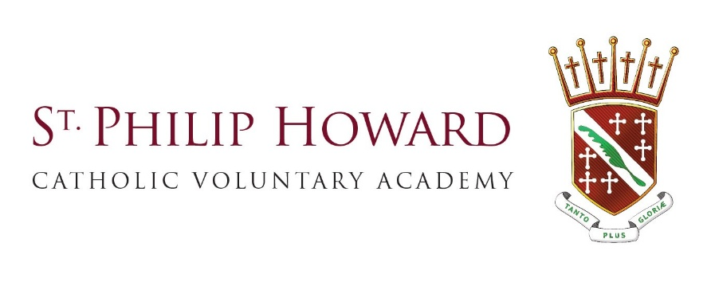
Dates for your Diary
Date | Event | Information
Monday 16th June | Year 6 SEND transition week 3
Monday 23rd June | Year 6 SEND transition week 4
Friday 27th June | Non-Uniform Day | £1 donation to Thomas Theyer Foundation
Monday 30th June | Year 6 Transition week & Year 10 Work Experience Week
Tuesday 8th July | Year 6 Parents Evening
Tuesday 15th July | Year 6 SEND Coffee Morning & Year 9 Spanish Tapas Trip
Thursday 17th July | Sports Day
Wednesday 23rd July | Rewards Trip
Thursday 24th July | Last Day of School & Non-Uniform Day | Food & Uniform Donations & School finishes at 12:15pm
Thursday 21st August |   GCSE Results Day

