5th March 2025

Dear Parent/ Carer,

I will shortly be ordering revision guides for Year 10 Spanish GCSE classes.

The CGP GCSE Spanish Revision Guide; Exam Practice Workbook (with online audio) and Vocabulary Book include all vocabulary for the GCSE exam and revision notes explaining all the required topics, along with complete exam practice and audio. This bundle costs £9.50.

If you would like to order copies for your child, please make payments via ParentPay by Friday 29th March.

If you have any further queries, please do not hesitate to contact me.

Yours sincerely,

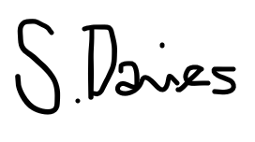

Mrs S. Davies

Head of Spanish