9th September

Dear Parent/Carer,

As you will be aware, Students attended their end of term Masses in the final weeks of Advent before Christmas. For the vast majority of the school community, this was an enjoyable experience and staff and students were reverent and engaged in the celebration together.

As a school community, we uphold British Values of mutual respect and tolerance for those of faith and different beliefs which is a legal requirement for all places of education or employment.

As a Catholic school, we invite all members of our community to celebrate the end of term and give thanks in a celebratory Mass which gives all the opportunity to pray or reflect together. Our Mission Statement clearly states that, ‘…We will take the SPH journey…respectfully as part of a united Catholic family’ and that, ‘respect for all will be at the spirit’ of this. This means that we will be respectful of one another’s beliefs and differences and by doing so, come together as a community with reverence.

This is expected when we attend Mass since this is a time to demonstrate respect for each other and those who have worked hard to organise the Mass (Mrs King our Chaplain, Father Martin our Parish Priest and the children involved in preparing music, singing or reading).

As a school, we are very fortunate to have our Parish Priest attend school and offer end of term Masses for us as a school and a number of Parishioners from the Church attend these as part of the school community.

However, in the recent end of term Mass, your child did not uphold the necessary reverence, expected standards or practices that we expect from our students.

These include the following:

1. Entering in silence and refraining from talking throughout Mass.
2. Being seated with their Form Group.
3. Following guidance and instructions from members of staff.
4. Listening respectfully and sitting reverently throughout Mass.
5. Being quiet so that others can pray or reflect.
6. Following the behaviour policy and being respectful to all.
7. Not using language, gestures, sounds or movement which may disturb or offend others.

Your child has been spoken to and/ or received a consequence for this and has been reminded about expectations. However, in order to ensure that they understand the expected practices, they will not attend the next Mass as calendared for their Form or Year group.

Instead, throughout the time in which others attend Mass, your child will have an informative and reflective session about why we attend Mass, and the different beliefs Catholics and other faiths have regarding worship. This is to support your child to understand the importance of being respectful to all and their different beliefs and practises.

Following successful completion of this session and the accompanying work supporting this, your child will then be able to attend Mass to demonstrate this in practice.

We hope that you can understand the importance of supporting our children to be respectful of different faiths but also the importance of being reverent and how to demonstrate this when others may wish to engage in prayer or reflection.

If you have any questions or queries, please do not hesitate to contact your child’s Form Tutor in the first instance or alternatively, their Head of Year.

Yours sincerely,
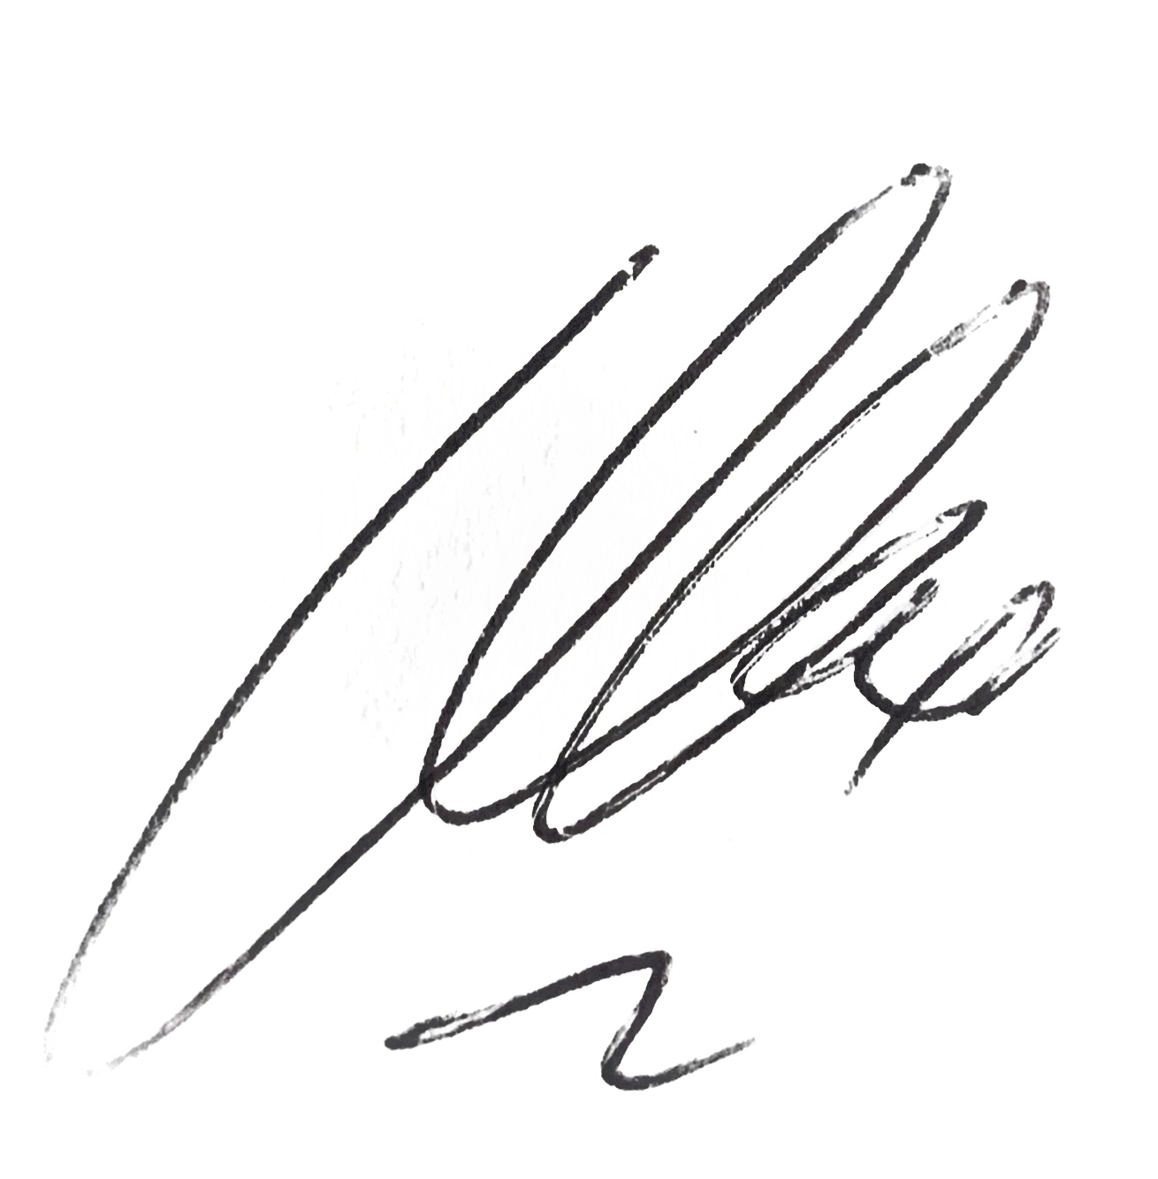

Miss K Cox

Senior Assistant Headteacher

