This statement details St Philip Howard RC Academy use of pupil premium (and recovery premium for the 2024 to 2025 academic year) funding to help improve the attainment of our disadvantaged pupils.

It outlines our pupil premium strategy, how we intend to spend the funding in this academic year and the effect that last year’s spending of pupil premium had within our school.

**School overview**

|  |  |
| --- | --- |
| **Detail** | **Data** |
| School name | St Philip Howard RC Academy |
| Number of pupils in school | 579 |
| Proportion (%) of pupil premium eligible pupils | 30% |
| Academic year/years that our current pupil premium strategy plan covers **(3 year plans are recommended)** | 2023-24 to 2026-2027 |
| Date this statement was published | December 2024 |
| Date on which it will be reviewed | June 2025 |
| Statement authorised by | M Kays |
| Pupil premium lead | K Cox |
| Trustee lead | S Lockyer |

**Pupil Premium Funding**

The Pupil Premium was introduced in April 2011 and gives schools extra funding to raise the attainment of pupils eligible for it from reception to year 11. The Government believes that the Pupil Premium, which is additional to main school funding, is the best way to address the current underlying differences between children eligible for the premium and their peers by ensuring that funding to tackle disadvantage reaches the pupils who need it most. The Government has allocated funding to support:

* Students in receipt of free school meals (FSM)or who have claimed free school meals in the last six years
* Students who are looked after by the Local Authority, and
* The children of Armed Service families

|  |  |
| --- | --- |
|  | **Pupil Premium Grant per pupil** |
| Pupils in Year group R-6 recorded as Ever 6 FSM | £1,320 |
| Pupils in Year group 7-11 recorded as Ever 6 FSM | £935 |
| Looked After Children (LAC) | £1,900 |
| Children who have ceased to be looked after by a local authority in England and Wales because of adoption, a special guardianship order, a child arrangements order or a residence order | £1,900 |
| Service children: Pupils in year groups R to 11 recorded as Ever 4 Service Child or in receipt of a child pension from the Ministry of Defence | £300 |

Students eligible for the pupil premium are identified in this school using data from the Department for Education’s “Key to Success” database. Funding is allocated from the January school census. Students who become eligible for free school meals whilst on the school’s roll are added to this cohort of students.

Total Pupil Premium Grant 2020/21 = £129,030 (Based on the October 22 Census)

|  |  |  |
| --- | --- | --- |
| Year | Number of Eligible Students (OCT 2023) | Total Students Y7-Y11 (OCT 23) |
| 7 | 31 | 113 |
| 8 | 35 | 118 |
| 9 | 35 | 118 |
| 10 | 41 | 118 |
| 11 | 33 | 112 |
| Total | 175 | 579 |

The Pupil Premium is paid to the school and it is for the school to determine how it is spent. The school is required to publish an annual plan for the use of its Pupil Premium funding and to publish an annual report evaluating the impact of the funding.

Looked after children (who have been “looked after” for one day or more) are eligible for £1900 of pupil premium funding. In Derbyshire this money is held by the Virtual School Headteacher for Children in Care. £300 per term of the grant can be released to schools using a system of provision mapping. Additional sums may be available by application. At St Philip Howard we currently have two students who fall into this category.

**Governance and Leadership of Pupil Premium Spending**

The governing body is responsible for approving the arrangements for the use of the Pupil Premium and for monitoring the impact of that spending. At St Philip Howard Academy.

The school’s annual Pupil Premium Plan is approved by the lead governor on pupil premium and the trust lead on Pupil premium. The Governors also receive termly reports on the impact of the Pupil Premium Plan and approves the school’s annual report on Pupil Premium spending and its impact.

At St Philip Howard Academy, the Assistant Head teacher (Curriculum) is the named staff member who leads on pupil premium work.

**Evidence and Context to Pupil Premium Spending at St Philip Howard Academy**

At St Philip Howard Academy, we are very much aware of an ever growing body of evidence documenting ‘best practice’ surrounding the use of Pupil Premium. We have also developed our own approach to the Pupil Premium since its inception in April 2011. Therefore, for 2023-2024, we have once again reviewed and revised the ways in which we are planning, budgeting, reviewing and then measuring the **impact** of our allocation.

Firstly, instance we continue to access the growing body of evidence provided by the EEF:

<https://educationendowmentfoundation.org.uk/evidence/teaching-learning-toolkit/>

Secondly, we have accessed and reviewed documents from the DfE and OFSTED:

* ‘The Pupil Premium, How schools are spending the funding successfully to maximise achievement.’ OFSTED (2013).
* ‘The Pupil Premium, How schools are using the Pupil Premium to raise achievement for disadvantaged pupils.’ OFSTED (2012).
* ‘Subject to Background, Sutton Trust, (2015).

Thirdly, we increasingly compare our experiences to other similar schools:

This evidence base has allowed us to formulate a set of principles to guide our use of the Pupil Premium:

* We will ensure that Pupil Premium funding is spent on students eligible for it.
* We are aware that within our Pupil Premium cohort there are a diverse range of needs – both existing and emerging.
* We will maintain high expectations of the Pupil Premium cohort
* We will thoroughly analyse which pupils are under-achieving and endeavour to work out why.
* We will use evidence to allocate funding to big-impact strategies.
* We will be relentless in our pursuit of high quality teaching, not interventions to compensate for poor teaching.
* We will use progress data to check interventions are effective and make adjustments where necessary.
* We will have a senior leader with oversight of how Pupil Premium funding is being spent.
* We will ensure that teachers know which pupils eligible for Pupil Premium.
* We will endeavour to demonstrate impact.
* We will have a named governor who will oversee and challenge our use of the Pupil Premium.

**Local Context**

St Philip Howard Academy serves a very polarised area. Our catchment covers three main areas of High deprivation, with these being in the top 30% when compared with national data, with one area being top 10%.

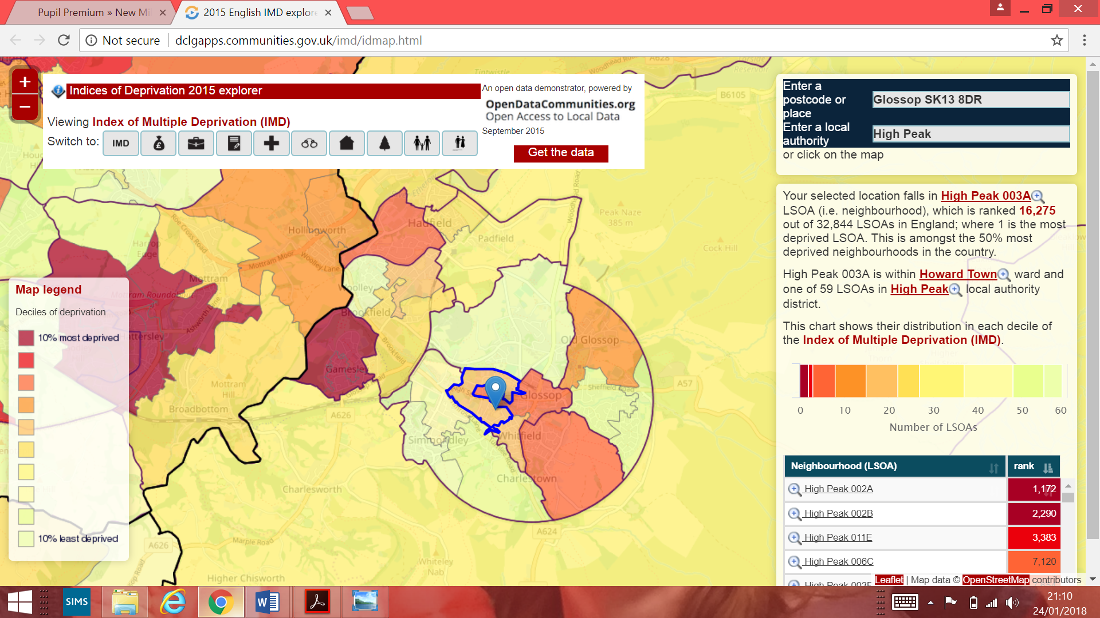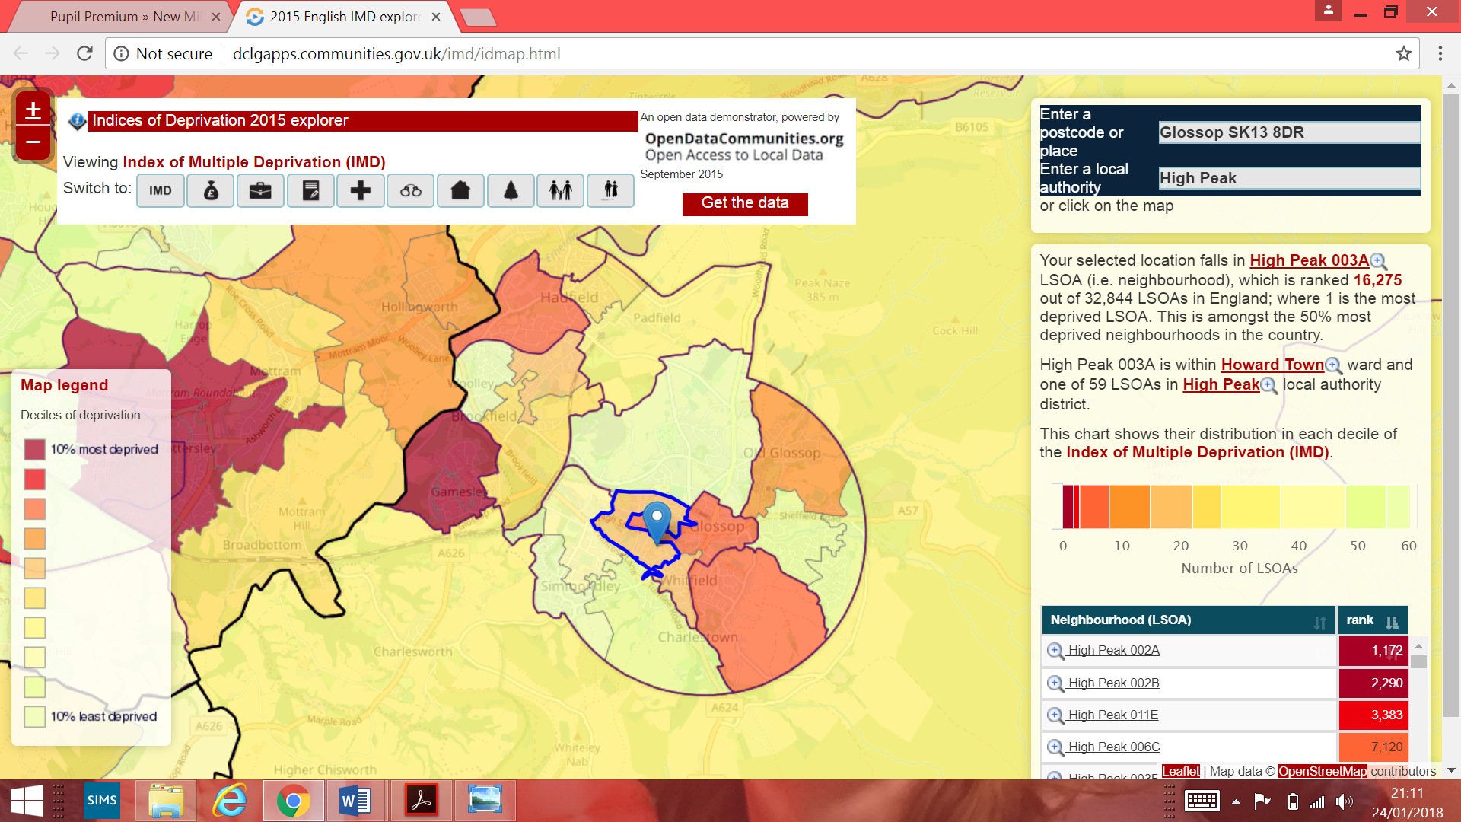

[*http://dclgapps.communities.gov.uk/imd/idmap.html*](http://dclgapps.communities.gov.uk/imd/idmap.html)

With this in mind we analyse, in detail, our Pupil Premium cohort in an attempt to identify common barriers and any local issues. The polarised nature of our cohort means that we cannot assume anything and are not always dealing with obvious or common local barriers. Therefore, a significant proportion of our work centres around monitoring the progress of our cohort and our ability to act quickly and address emerging needs. We recognise that our Pupil Premium cohort has a diverse range of aspirations, prior attainment and levels of progress. Some of our brightest and most talented students form part of our Pupil Premium cohort. We have increased our capacity to identify and react on a daily basis. Our staffing is a key area of our intervention strategy. Staff are tasked with identifying barriers and reviewing progress through our reporting system along with book scrutinise and lesson observations. We rely heavily on our Heads of year, Heads of departments to identify needs and deliver interventions. At the same time, historically, we have evidence that points us towards broad barriers in the High Peak area:

* Family history of reduced engagement with school life such as attendance at parent consultation evenings
* A lack of aspiration towards attending leading universities
* Ability to engage with extra-curricular activities and Period 6 intervention
* Sudden loss of family income resulting in non-engagement with educational visits and sudden reduced ability to purchase school equipment

All of our strategies can be linked to these local issues.

**Funding overview**

|  |  |
| --- | --- |
| **Detail** | **Amount** |
| Pupil premium funding allocation this academic year | £165,892 |
| Service Pupil Premium | £0 |
| Pupil premium funding carried forward from previous years (enter £0 if not applicable) | £0 |
| **Total budget for this academic year**  If your school is an academy in a trust that pools this funding, state the amount available to your school this academic year | £205, 642 |

**Statement of intent**

At #TEAMSPH our objectives for pupils who have necessary tools and are in receipt of PP funding are threefold:

1. To ensure all PP students make progress in line with their peers in all subjects
2. To ensure a childhood set of experiences at least in line with their peers.
3. To ensure all students receive additional and specialised intervention so they make informed choices about the next stage of their learning

In order to achieve the objectives above #TEAMSPH will focus on the following key principals:

1. **All PP pupils will make academic progress in line with their peers**

Exceptional teaching is at the heart of ensuring PP students make progress in line with their peers. At #TeamSPH we will ensure all PP pupils receive the very best teaching in every subject. The pandemic has also meant that some PP pupils have fallen further behind in some subjects. We will ensure recovery in line with their peers through: dedicated and personalised intervention strategies, inclusion in the national tutoring programme initiative and all staff adhering to the **‘PP First’** initiative.

1. **All PP Pupil’s attendance will be above or in line with national average attendance**

Attendance will be assured through a rigorous attendance strategy partnered with supportive home school dialogue. Every effort will be made at all levels including tutor, House, attendance officer and other agencies, to ensure sustained attendance is achieved.

1. **All pupils will be supported to foster independent learning, greater autonomy and self-directed learning through teaching strategies, extracurricular activities and supportive personalised pastoral care.**

All PP students will have access to a tutor who will ensure the conditions for learning in school and at home do not hinder academic progress or attainment. Teaching strategies and whole school initiatives will strive for PP pupils gaining greater autonomy, resilience and being able to self-direct their learning.

1. **All PP pupils will take part in a childhood set of activities which broaden pupil outlook and perspectives.**

There is much evidence to suggest that those in receipt of pupil premium funding do not always experience a rich set of activities and opportunities which broaden their outlook and perspective. This has been further compounded by the national lockdowns and the pandemic.

#TeamSPH will ensure a memorable set of experiences which support engagement and independent growth.

**5. All PP pupils will take part in C.E.I.A.G. (Careers Information Advice and Guidance) activities which broaden knowledge of careers and ensure informed choices as to the next steps of their learning from year 7.**

#TeamSPH will ensure an enhanced CEIAG package of activities which will include personalised mentoring and dedicated careers interviews. The pandemic has reduced the opportunities for face to face discussions on career opportunities and detailed discussion on next steps in learning, career development and progression routes.

**Challenges**

This details the key challenges to achievement that we have identified among our disadvantaged pupils.

|  |  |
| --- | --- |
| **Challenge number** | **Detail of challenge** |
| 1 | External reading assessments (Star reading) in Year 7 indicate that of the lowest 20% of readers, 17% of them are disadvantaged students  External GL assessment CAT scores in Year 7 indicate that of the 11% of students with CAT scores less than 90 (Average is 100), 40% are disadvantaged students.  External assessments for Year 7 students show that of the 6% of students gaining very high standard age scores, (SAS scores >126) none are disadvantaged and 90% our most able students (top 20% of the cohort) are non-disadvantaged.  External reading assessments (Star Reading) in Year 8 indicate that of the lowest 20% of readers, 11% of them are disadvantaged students  External GL assessments CAT scores in Year 8 indicate that of the 30% of students with CAT scores less than 90 (Average is 100), less than 1% are disadvantaged students.  External assessments for Year 8 students show that 5% of non-disadvantaged students account for the very high standard age score of >126 of which none are disadvantaged students |
| 2 | 2023 results suggest that the progress of our disadvantaged students is -0.43 but is improving over time and in year data shows this is a continued improving picture. |

|  |  |
| --- | --- |
| 3 | results for Year 11 in 2022-2023 indicated that overall attainment for disadvantaged was 2.8 but broadly in line with the pupils FFT target data. |
| 4 | Our safeguarding data shows that referrals made in 2023 had a slightly higher proportion disadvantaged students. Additionally, the impacts of mental health and strains placed on families with the disruption of schooling due to COVID, means that students from disadvantaged backgrounds can often require more support from schools. |
| 5 | **Some, but not all** PP pupils start year 7 with a fixed mindset of their ability and prospects. |
| 6 | **Some, but not all** PP students lack positive role models and thus lack guidance with future progression options. |

**Intended outcomes**

This explains the outcomes we are aiming for **by the end of our current strategy plan**, and how we will measure whether they have been achieved.

|  |  |
| --- | --- |
| **Intended outcom** | **Success criteria** |
| **All PP pupils will make academic progress in line with their peers** | * Outcomes in all subjects matches that of their peers |
| **All PP Pupil’s attendance will be above or in line with national average attendance** | * Attendance data for all PP pupils in line with or above national. |
| **All pupils will be supported to foster independent learning, greater autonomy and self-directed learning through teaching strategies and supportive personalised pastoral care** | * Staff successfully employing teaching strategies which foster independent learning. * PP participation in whole school initiatives such as wider reading schemes or Powerful Words project. * Tutors employing a **‘PP First’**   Strategy. |
| **All PP pupils will take part in a childhood set of activities which broaden pupil outlook and perspectives.** | * PP pupils supported to participate in curriculum enhancement opportunities (Wymondham Life), including access to course/study |

|  |  |
| --- | --- |
|  | related trips (e.g. Geography field trip)   * All PP pupils to attain the Floreat Diploma by the end of Year 9 |
| **All PP pupils will take part in C.E.I.A.G. (Careers Information Advice and Guidance) activities which broaden knowledge of careers and ensure informed choices as to the next steps of their learning from year 7.** | * Fully participating in school’s KS3 careers programme:**.** * Having at least two independent careers interviews at KS4. * Being mentored by a specialist mentor during KS4. * All PP students making successful progression choices by the end of KS4 |

**Activity in this academic year**

This details how we intend to spend our pupil premium (and recovery premium funding)

**This academic year** to address the challenges listed above.

Please use the following link to see a detailed plan on how the funding will be used this year.

# Part B: Review of the previous academic year (Provisional Pre-validated results)

**Outcomes for disadvantaged pupils**

We have analysed the performance of our school’s disadvantaged pupils during the 2022/23 academic year using key stage 4 performance data and our own internal assessments.

For 2024, the Progress 8 score for our disadvantaged pupils was -0.43. For Attainment 8 it was 28

We have, compared our results to national figures to help gauge the performance of our disadvantaged pupils (although these should be considered with caution given the caveats stated above). The national Attainment 8 score for disadvantaged pupils in 2023/24 was 37.5 and for non-disadvantaged pupils it was

52.6. For Progress 8, the national average score for disadvantaged pupils was –0.55 and for non-disadvantaged pupils it was 0.15.

Key stage 4 data and our internal assessments suggest that the progress of the school’s disadvantaged pupils in 2023/24 in line with expectations.

We have managed to close the gap between the Progress 8 and Attainment 8 scores of our disadvantaged and non-disadvantaged pupils since the start of the pandemic. The Progress 8 score of our non-disadvantaged pupils was 0.36 compared to -0.4 for our disadvantaged students, and who’s Attainment 8 score was 49. Our analysis suggests that the reason for this is primarily the ongoing pursuit of providing equal opportunities for our disadvantaged students and our relentless drive to raise aspiration and achievement for all.

Absence among disadvantaged pupils was 6.4% higher than their peers in 2023/24 We recognise this gap is too large which is why raising the attendance of our disadvantaged pupils is a focus of our current plan and main part of our school improvement plan.

These results mean that we are at present on course to achieve all of the outcomes that we set out to achieve by 2023/24, as stated in the Intended Outcomes section above. We have reviewed our strategy plan and made minor changes to how we intend to use some of our budget this academic year, as set out in the Activity in This Academic Year section above.

**Externally provided programmes**

|  |  |
| --- | --- |
| **Programme** | **Provider** |
| Progress tests in maths and English | GL Assessment |
| Reading tests | GL Assessment/ Star Reading |
| Vocabulary enhancement | Bedrock/Powerful Words |