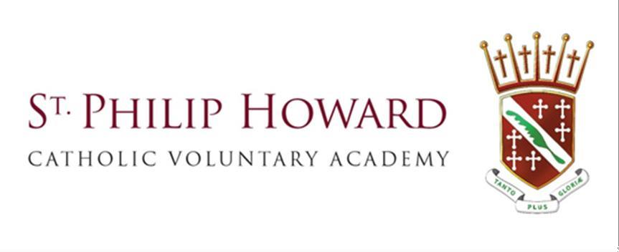

Home-School Communication Charter

**2024-2025**

**Mission Statement**



Together**, we will make the SPH journey: safely, respectfully and with kindness as part of a** united Catholic family.

God **will be at the heart of our journey, supporting us to realise the potential of our** God given talents.

Our Gospel Values **will guide us on our journey, helping us to make** brave choices **along the way.**

Respect for all **will be at the spirit of our journey and we will** embrace the uniqueness **of everyone we greet.**

Inspiration and passion for learning **will lead us all to have a** memorable and successful **journey.**

# Home - School Communication Charter

Communication between home and St Philip Howard Catholic Voluntary Academy is vital when sharing information and for the well being of pupils, parents, carers and staff.

This Charter sets out how communication will be managed to make sure it is productive.

In addition to parents’ evenings, school events, etc., there may be occasions when parents or carers wish to communicate with the St Philip Howard Catholic Voluntary Academy directly with questions or information related to their child.

To make sure that this is effective these principles will be applied.

If an emergency situation arises, it is important that you contact us as soon as possible and explain what has or is happening.

# Our commitment as a school We will:

* ensure that there is regular, proactive communication about your child’s achievement and wellbeing
* respond to emails, phone calls or requests for meetings usually within three working days
* if there is an urgent matter, the school receptionist will ask an appropriate member of staff to deal with the issue as soon as possible
* display polite, professional conduct at all times
* acknowledge receipt of an email – and confirm that a fuller response will be sent within three working days.

# Our expectations of parents and carers You will:

* ensure that any communication with the school, whether by email or telephone, is polite and respectful
* make use of information channels in place, such as the school website, for keeping up to date with routine information
* give an outline of what the issue is, to make sure the query is directed to the right person
* use the school mailbox or main reception telephone number as first point of contact (the school will forward your request to the appropriate staff member)
* ensure your emails are brief and clear
* refrain from sending multiple emails regarding the same query
* limit the number of people you send an email about a query
* understand that a teacher or member of staff may be unable to respond on the same day on which a query is made
* understand that teachers or other school staff will not respond outside of school hours, i.e., evenings or weekends

If there is an in person meeting, everyone must show mutual respect. The meeting will focus on resolving the issues that are relevant to that family or pupil.

No offensive language, insults or personal attacks on school staff will be tolerated. If any such incidents occur, the meeting can be terminated with immediate effect.

No meetings or conversations shall be recorded without the knowledge and consent of all parties to the meeting.

The constraints on school resources make it essential that parents and carers use authorised school procedures in order to avoid diverting time and attention that must be invested directly in pupils’ learning and wellbeing.

Please note that unreasonable, abusive or offensive communication is unacceptable, and the school reserves the right to address any such problems as they feel are appropriate. This can include restricting correspondence to a specified email address, using a single person as a point of contact or using hard copy post and/or by placing restrictions on phone calls. Parents and carers have an implied licence to enter a school site, in cases where behaviour is inappropriate, threatening or argumentative, this licence can be revoked.

If a response has been given to a query, unless matters change, further responses will not be sent.

Our aim is to ensure that all communications and discussions about pupils and their families are positive and move matters forward in a mutually respectful manner.