Dear Parent/ Carer,
As you will be aware, your child’s external/ GCSE examinations begin on 6th May 2024. This means that Students have approximately 13 weeks of curriculum time in school leading up to this. In order to support your child and enable you to support them too, we have organised a number of additional interventions which should help them with their revision and preparation leading up to the exams. The dates of these and a short explanation can be found below.

Extended Learning Timetable starts:  Monday 15th January | Students receive a timetable of extra revision sessions which will take place before school (Period 0), at lunch or after school (Period 6).
Core Pomodoro Session:  Tuesday 23rd January  (3.15- 5.30 pm) | This is a session for Students to take part in short-focused study periods in the Hall focused on English, Maths, Science or RE with specialists from those Subject Areas supervising for them to ask any questions should they need any support. *During the break, Students receive pizza as a reward for their effort and concentration- as will be the case in all Pomodoro sessions.
KS4 Parents’ Information Evening:  Thursday 25th January  (4.30- 6.45 pm) | Parents are invited into school to meet with Core Heads of Department and Subject teachers for English, Maths, Science and RE. The sessions will provide you with information about the course content and exams, as well as how to support your child at home.
Year 11 Parents’ Evening:  Thursday 1st February. | This is an opportunity to meet with all of your child’s subject teachers to discuss their progress and how they can maximise their learning over the coming weeks.
Year 11 Core Subject Mocks:  Monday 5th February-  Friday 16th February | This is the final opportunity for Students to sit mock exams in Maths, English and RE followed by Science in the weeks after this. Other subjects may also offer practice papers for completion in lessons during this time.
Year 11 Options Subjects Pomodoro:  Tuesday 13th February | This is a session for Students to take part in short, focused study periods in the Hall focused on their options subjects with specialists from those areas supervising in order to offer any support should they need it.
February Half-term Revision Sessions  Monday 19th February-  Friday 23rd February | During half-term, Students will have an opportunity to attend some additional revision sessions in school and online.

*More detail for the most imminent events can be found below or in the attachments provided.

From next week, starting Monday 15th January all Students will be required to attend the sessions outlined in the Extended Learning Timetable as applicable to their class or Options Subjects. (The timetable for this can be found as a separate attachment). Please note that for sessions which state, ‘Targeted intervention’, this will be by invite only and Students and Parents will be informed by Subject Leaders for this subject ahead of the sessions which they will need to attend. Attendance for all Extended Learning Sessions will be monitored by Heads of Department to maximise Students’ learning and ensure Students are engaging with the targeted support on offer to them.
The Pomodoro Session for Core Subjects on 23rd January consists of four 25-minute sessions of revision with two 5 minute breaks and one 20 minute break as proven scientifically to be the best way for Students to maintain focus and concentration and maximise learning and retention. An overview of this can be found below:

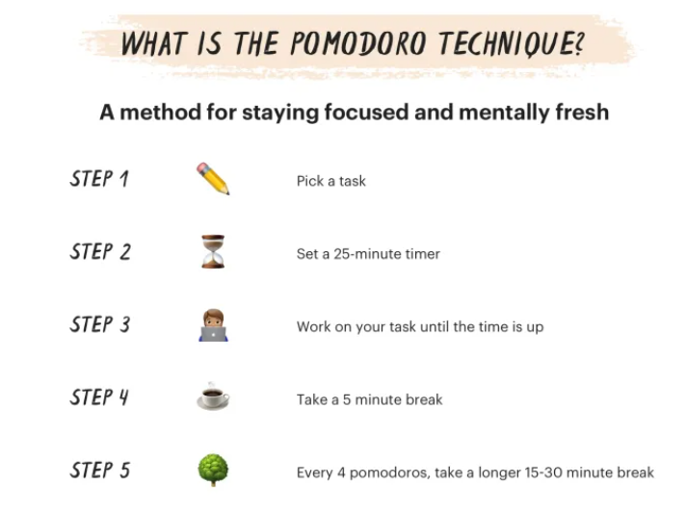

The Key Stage 4 Parents’ Information Evening that will be taking place on Thursday 25th January and will be focused on Core Subjects. This evening will be crucial in offering you support to further enhance your child's studies. The Parents' Information Evening will take place from 4.30- 7pm and will be targeted at Parents.
To confirm your attendance, we ask you to book an appointment using School Cloud. In this instance, you will book with your child’s Form Tutor so they have a record of the Parents of Students in their Form that will be attending. The evening will begin with an introduction to revision, followed by sessions of approximately 20 minutes led by Heads of Department or subject specialists in each core subject, specific to the tier/ entry for your child. Information packs will also be provided for you to aid discussions with your child about content and revision at home and any additional questions can be answered at the end of each session.

Finally, the Year 11 Parents’ Evening will be taking place on Thursday 1st February. This Parents’ Evening will be taking place in school but again, bookings will be made via School Cloud with your child’s subject teachers in the usual way. Instructions for how to do this can also be found attached.

Bookings for this and the Parents’ Information Evening will be open from the end of today: Friday 12th January.

Further information regarding the events following this will be provided to you in due course. However, if you have any questions regarding any of the above, please contact your child’s Form Tutor or Subject-specific Class Teacher in the first instance, followed by the Head of Year and myself, should you have any further concerns or queries.

Thank you in advance for supporting your child in their studies and encouraging them to engage with the additional support we have on offer.

Yours sincerely,

Kerrie Cox

Senior Assistant Headteacher

