5th September 2023

Dear Parent/ Carer,

We hope this letter finds you and your families safe and well.

Due to the anticipated warm weather this week pupils are allowed to wear their uniform without their school jumpers. We will be advising pupils to take off their blazers when in classrooms and come prepared to school with a water bottle. Pupils are required to wear the rest of their uniform including school shoes. We will review the uniform situation throughout the week and keep you informed on any further updates or adaptations that may need to be made.

We look forward to welcoming your child back look forward to another successful year.

Yours sincerely,

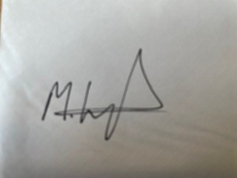

Mr Kays

Headteacher