Dear Parent/ Carer,

As you will be aware, the PGL Revision Residential will be taking place on Monday 18th September- Wednesday 20th September. Thank you for offering your support and giving permission for your child to attend.

**Time of departure and return:**

The coach will leave school at 11.45 (after an early lunch in school) on Monday 18th September.

Students will return to school for approximately 3.30 on Wednesday 20th September.

**Rooms:**

Students will be allocated rooms for between 4, 6 or 8 people. These will be decided in discussion with Students ASAP but by no later than Friday 15th September. Rooms have en-suite bathroom for Students to share.

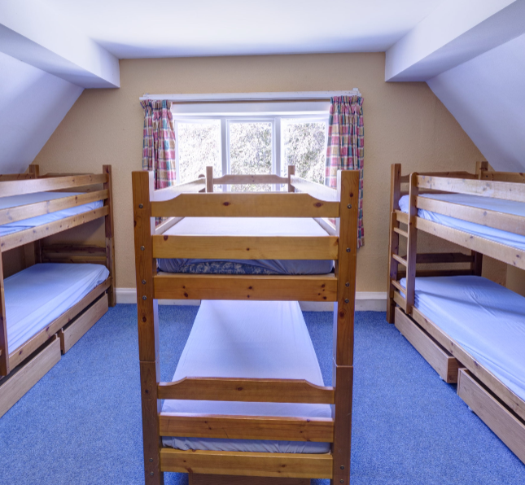

**Itinerary:**

Students will take part in a number of sessions throughout each day. The timings for these can be found below. On Monday, the first session will start at 2pm. On Wednesday, the last session will end at 12.10pm.



The revision sessions will be focused sessions for Maths, English and Science on key skills/ topics and questions that are typically more difficult in the exams. Staff will teach and focus on key knowledge required to at least achieve a grade 4/5. (The sessions will be led by Miss Elliott, Mrs Barber, Mr Cook, Miss Wright and Mr Fitton with support from Miss Speakman).

The physical activities Students can take part in include: abseiling, raft building or zipwire. Following Students’ evening meal, there will also be evening team-building activities/ entertainment such as campfire activities or quiz shows. Should Students wish to continue studying during this period, Miss Speakman, Mr Cook or Mrs Barber will be available to help with this.

**Requirements:**

The kit Students will need to bring can be found in this pack.

**Meals and snacks:**

A typical menu for all meals can also be found in this pack.

*PGL can cater for a wide variety of food requirements when notified in advance, including allergies, intolerances, medical conditions, and those specified by culture and religion. (Please make a note of these on the permission slip provided).

Should you wish to find out any additional information regarding your child’s safety or the place in which your child will be staying, this can all be found on the Winmarleigh Hall website:

<https://www.pgl.co.uk/en-gb/adventure-holidays/centres/winmarleigh-hall>

Should you have any concerns or queries or concerns, please do not hesitate to me via email: kcox@sph.srscmat.co.uk

**Please complete the additional information and confirmation of consent, ensuring it is returned to me via email or paper copy on Friday 8th September** so that we can discuss rooms and update Students with more detailed plans for the trip in the week commencing 11th September.

Yours sincerely,

Kerrie Cox

**Senior Assistant Head-teacher**

**St Philip Howard Catholic Voluntary Academy**

**Telephone:** 01457 853 611 **Extension:** 205

**Email:** kcox@sph.srscmat.co.uk

**Name of Student: ………………………………………………. Date: …………………………………………………**

**I give permission for my child to attend the PGL on 18th- 20th September: YES NO**

Winmarleigh Hall  
Church Lane  
Winmarleigh  
Preston  
Lancashire  
PR3 0LA

**I understand the kit requirements and will ensure my child is appropriately equipped: YES NO**

**I have discussed the different activities my child will be taking part in. He/ She knows she must be fully engaged in any Maths/ English/ Science sessions and give permission for my child to take part in physical activities too.**

**YES NO**

**Additional needs/ support that may be required:**

**……………………………………………………………………………………………………………………………………………………….**

**My child has an allergy: YES NO**

**Details: …………………………………………………………………………………………………………………………………………..**

**Medication: ……………………………………………………………………………………………………………………………………**

**……………………………………………………………………………………………………………………………………………………….**

**How often is this taken? How is it stored? (I understand that this will be held by a member of Staff and administered as appropriate. If this is not possible, please indicate below).**

**……………………………………………………………………………………………………………………………………………………….**

**I have spoken to my child about safety and behaviour expectations and they understand that the same rules will apply as being in school. YES NO**

**Signed: ……………………………………………… Parent/ Carer’s name:…………………………………………………………..**

**Telephone: ……………………………………………………………. Email: ………………………………………………………………**

**Any other detail/ important information: ………………………………………………………………………………………….**

**…………………………………………………………………………………………………………………………………………………………….**